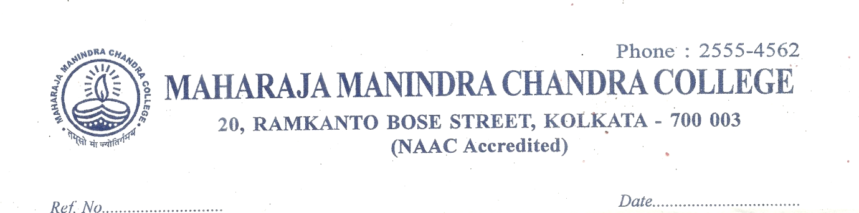
B.Sc. HONOURS COMPUTER SCIENCE CBCS SEM VI PROJECT DETAILS (CC-13 AND CC-14)
Name | Roll Number | Registration Number | Project Name
Ava Rani Pal | 203211-11-0055 | 211-1214-0447-20 | SMART PARKING SYSTEM
Bristi Bhattacharjee | 203211-11-0037 | 211-1211-0449-20
Ahana Manna | 203211-11-0059 | 211-1211-1078-20
Sujan Mukherjee | 203211-21-0065 | 211-1111-0442-20 | Project Report on online voting system
Soumyajit Roy | 203211-21-0074 | 211-1111-0460-20
Ronith Goon | 203211-21-0070 | 211-1111-0453-20
Arghya Sen | 203211-21-0067 |  | Face Mask Detection using Python
Avas Saha | 203211-21-0085
Abhishek Roy | 203211-21-0087
Ayush Kumar Singh | 203211-21-0068 | 211-1111-0448-20 | Project Report on Library Management System
Subhomoy Paul | 203211-21-0096 | 211-1114-0463-20
Sinchan Nandi | 203211-21-0071 | 211-1111-0457-20
Deep Saha | 203211-21-0064 | 211-1111-0439-20 | Project Report on  Online House/Hostel Rental Service web application
Biswajit Ray | 203211-21-0076 | 211-1111-0469-20
Sima Mondal | 203211-11-0050 | 211-1212-0456-20
Asima Bag | 203211-11-0036 |  | Project report on Air pollution monitoring system
Soumili Ray | 203211-11-0043 | 211-1211-0471-20
Adrita Bardhan | 203211-11-0035 | 211-1211-0444-20 | Driver’s drowsiness detection system
Tandra Mallick | 203211-11-0040 | 211-1211-0465-20
Simran Gain | 203211-11-0044 | 211-1211-0472-20
Hritik Dey | 203211-21-0069 | 211-1111-0450-20 | Jarvis: The Personal Windows Assistant
Debarpan Mondal | 203211-21-0097 | 211-1111-0470-20
Suvendu Chowdhury | 203211-21-0066 | 211-1111-0443-20
Tanisha Roy | 203211-11-0041 | 211-1211-0466-20 | Designing and Developing fire and smoke system using Arduino interface with call and SMS alert
Debojit Pal | 203211-21-0063 | 211-1111-0438-20
Anima Mahato | 203211-11-0034 | 211-1211-0436-20

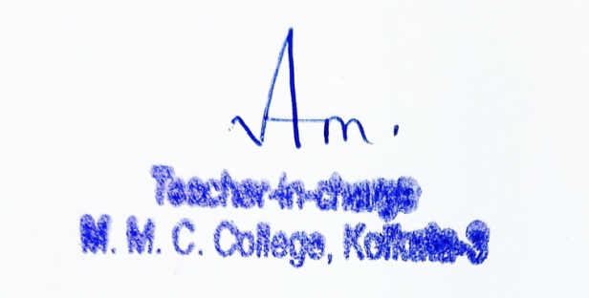

Soumyadeep Dey | 203211-21-0075 |  | ATM Management system in Java
Preeti Dhar | 203211-11-0038
Rimpa Rajbanshi | 203211-11-0047
Snehasis Kundu | 203211-21-0072 |  | Code Sensei-Education ChatBot
Sougata Roy | 203211-21-0073
Srijit Pal | 203211-21-0095 | 211-1114-0462-20 | An E-Commerce website for Indian Handicrafts
Suravi Basu | 203211-11-0039 | 211-1211-0464-20
Anuska Saha | 203211-11-0042 | 211-1211-0468-20

